

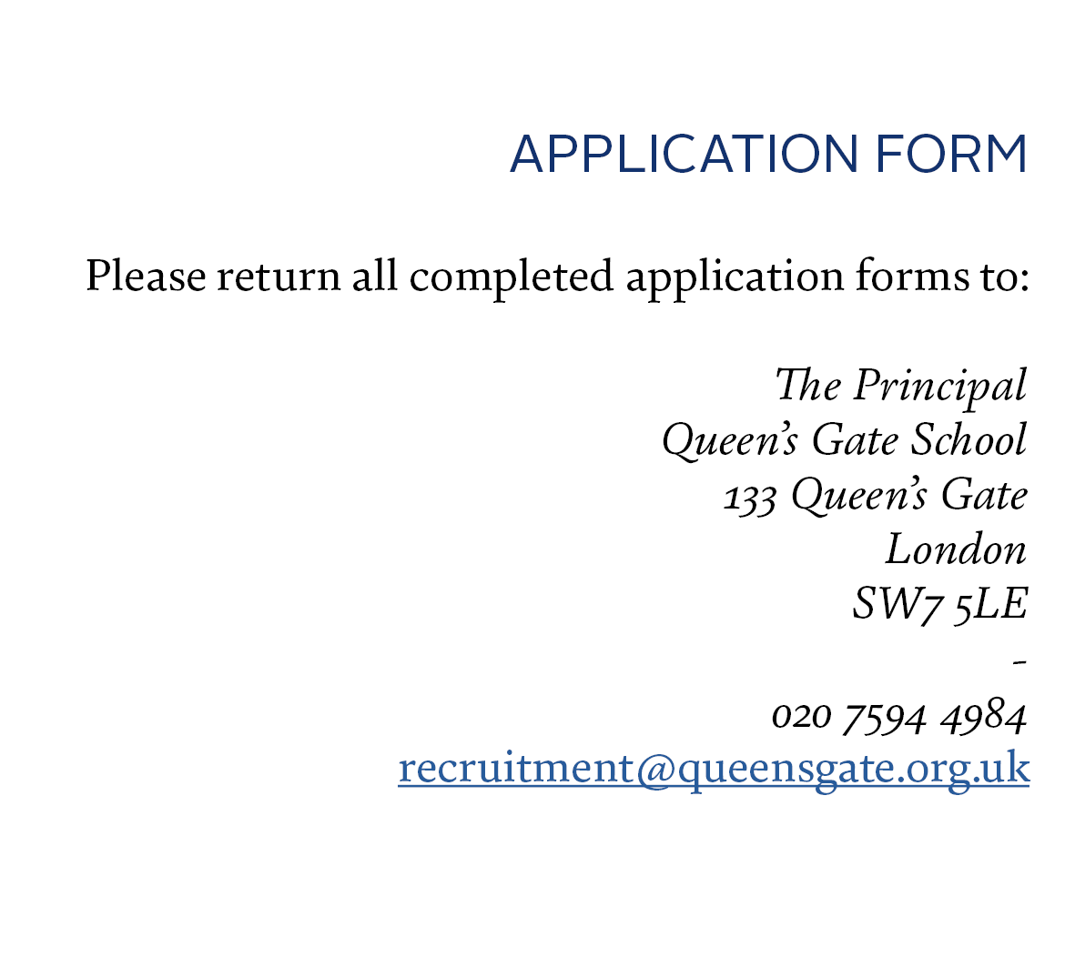
The information given on this form will be treated as STRICTLY CONFIDENTIAL
and processed in accordance with the General Data Protection Regulations 2016 (as applicable) the UK General Data Protection Regulations, the Data Protection Act 2018 and any subsequent amendments, as well as in accordance with our Privacy Notice at:
http://www.queensgate.org.uk/about-us/policies/

NAME:

POSITION APPLIED FOR:

CLOSING DATE:

Thank you for requesting an application form for the above vacancy. The School is legally required to carry out a number of pre-appointment checks which are detailed in our Recruitment, Selection and Disclosures Policy and Procedure. The information that you are being asked to provide in this form is required so that the School can comply with those legal obligations should your application be successful. Please note that in order to be considered for a position at the School, you must complete this application form as fully and effectively as possible. A CV will not be accepted in addition or in its place, as all relevant information should be contained in this form. A short covering letter of application is requested. Your application and short covering letter may be sent by e-mail or by post to the addresses given above. If your application is sent by e-mail, you will be required to sign the form if invited for interview.

Data Protection

The information you provide on this application form will be processed as stated above. The information given on this form may be also used for purposes of equality monitoring and compiling statistics. Queen’s Gate School will hold your application form on your personal file if successfully appointed to the position. If unsuccessful, the School will retain your application form for a period of 6 months and thereafter will destroy it accordingly.

Equal Opportunity

Queen’s Gate School promotes employment practices designed to eliminate discrimination and to ensure adherence to legislation and appropriate codes of practice. We include Equal Opportunity Monitoring questions at the end of this form. You are not obliged to answer any of these questions, which are included for equality monitoring purposes only.

Safeguarding

Queen’s Gate School’s Safeguarding and Child Protection policy can be found here.

- PERSONAL INFORMATION:
(BLOCK CAPITALS PLEASE)

Full Name: |  |  |  | Title:
Former Name(s):
Address:

Postcode:
How long have you lived at this address?
If less than 5 years, please provide all previous addresses for the past 5 years below:
Previous address:

Postcode:
Dates at this address:
Previous address:

Postcode:
Dates at this address:
Home Telephone No: |  |  |  | Mobile Telephone No:
Work/Other Telephone No: |  |  |  | Please state the preferred contact number:
E-mail Address:
Teacher Registration Number (teaching posts only):
Do you have Qualified Teacher Status? (teaching posts only): |  | Yes/ No  Date of obtaining QTS:
National Insurance Number: |  |  |  | Are you currently eligible for employment in the UK? |  | Yes/No  Please provide details , including any restrictions on your stay or on your right to work in the UK
- EDUCATION AND QUALIFICATIONS:

Please give details of all education i.e. secondary, further and higher education qualifications undertaken or being undertaken in chronological order

Dates of attendance | Name of School/College/University |  | Qualification Studied |  | Awarding Body |  | Grade Obtained and Date

- TRAINING AND DEVELOPMENT

Please give details of all training and development you have undertaken which are relevant to this application
(continue on a separate piece of paper if necessary)

Date | Name of Training Course (and award if gained) | Training Provider | Duration of course:

- PRESENT EMPLOYMENT:

If you are currently not in employment, please state this in the Job Title box below.

Job Title:

Employer’s Name:

Address:

Location/Country:

Date Started:

Current Salary (gross):
Please also note any additional employee benefits
Period of Notice:

Reason for wanting to leave:

Please outline your duties and responsibilities (continue on a separate sheet of paper if necessary).

- PREVIOUS EMPLOYMENT:
Give details of all your previous jobs since leaving school, including voluntary and paid work and any other positions held with your present employer
References may be sought from your previous employers.

Dates of  Employment: |  | Name, Address and Location of Employer: | Position Held: | Duties: | Reason for leaving:
Month/year  From: | Month/year  To:

- GAPS IN YOUR EMPLOYMENT
If there are any gaps in your employment history, when you have not been in education, training or employment, please give details and dates

- FURTHER DETAILS
Please detail how your knowledge, skills and experience meet the requirements for the post and why you are applying for it
(please refer to the job description and person specification included in the application pack).

Please also give any information that you think will support your application, include relevant experience, skills and any specialist knowledge you feel that you can offer. (Continue on a separate sheet of paper if necessary).

What have been your three main achievements in your current or previous employment?

1.

2

3.

- ACTIVITIES AND INTERESTS

Please state briefly your personal interests, hobbies or skills, particularly those which could be of benefit to the School for the purposes of enriching its extra- curricular activity.

- PROFESSIONAL MEMBERSHIP

Date: | Professional Body Name: |  | Membership No: | Grade/level

- DETAILS ON ONLINE PRESENCE

Keeping Children Safe in Education 2022 (KCSIE) asks schools to carry out online searches on shortlisted candidates as part of the process of assessing a candidate’s suitability. Please see our Recruitment, Selection and Disclosures Policy for further information.

You (and all other candidates) are therefore required to provide the following information as part of your application:

- the social media platforms on which you have accounts;
- the names/handles for all of your social media accounts, including any under a nickname or pseudonym;
- any websites you are involved with, in or featured or named on; and
- any other publicly available online information about you of which the School should be made aware.

If you are shortlisted for the role, we may carry out online searches based on the information you provide below. If we carry out searches, we will also search more widely for any other online information about you. You are not required to provide account passwords or to grant the School access to your private social media accounts.

If you are not shortlisted for the role, online searches will not be carried out on you.

- REFEREES

Please list below the names and addresses of two referees, one of which must be your current or most recent employer. If your current/most recent employer does/did not involve work with children, then your second referee should be from your employer with whom you most recently worked with children. Neither referee should be a relative or someone known to you solely as a friend. The School intends to take up references for short-listed candidates before interview. The School reserves the right to take up references from any previous employer. Please note that your current or most recent employer will be asked about any disciplinary offences relating to children and whether you have had any concerns raised about you regarding the safety and welfare of children.

If the School receives a factual reference i.e. one which only contains limited information about you, additional references may be sought.

If you have previously worked overseas, the School may take up references from your overseas employer(s).

The School may also telephone your referees in order to verify the references that they have provided.

If the School feels it is necessary to take up additional references for any reason, we will contact you to discuss this before approaching any party for an additional reference.

The School treats all references given or received as confidential which means that you will not usually be provided with a copy.

Reference One:  (Current or most recent employer) | Reference Two:  (Former employer)
Name: ________________________Mr/Mrs/Miss  Job Title: ______________________________  Company Name: _______________________  Email: _______________________________  Address: ______________________________  _____________________________________  _____________________________________  Tel No:________________________________  May we contact this referee without asking you?  YES NO  Office use:  Date requested: ________________________________  Date received: _________________________________ | Name: ________________________Mr/Mrs/Miss  Job Title: ______________________________  Company Name: _______________________  Email: ________________________________  Address: ______________________________  _____________________________________  _____________________________________  Tel No:________________________________  May we contact this referee without asking you?  YES NO  Office use:  Date requested: ________________________________  Date received: _________________________________

- OTHER INFORMATION

Please give details of any employee, pupil, consultant, volunteer, or Governor of Queen’s Gate School to whom you are related. If you fail to disclose such information you may be disqualified from consideration or, if appointed, liable to dismissal.

CANVASSING ANY OF THE ABOVE PEOPLE IN CONNECTION WITH THIS APPOINTMENT WILL DISQUALIFY YOU FOR APPOINTMENT.

NAME:___________________________________________________

RELATIONSHIP: _________________________________________

NAME:___________________________________________________

RELATIONSHIP: _________________________________________

NAME:___________________________________________________

RELATIONSHIP: _________________________________________

- SPECIAL ARRANGEMENTS FOR INTERVIEW

If you are called for interview, are there any special arrangements that need to be made for you to attend the interview and/or are there any special circumstances relating to you of which the School should be aware?

Yes/No

If you have answered “yes”, please specify the arrangements that you require and/or your special circumstances:-

- PROHIBITION FROM TEACHING, PROHIBITION FROM MANAGEMENT, DISQUALIFICATION FROM PROVIDING CHILDCARE,
DISCLOSURE AND BARRING SERVICE CHECKS, CRIMINAL RECORD AND CHILDREN’S BARRED LIST
The School is not permitted to employ anyone to carry out “teaching work” if they are prohibited from doing so. For these purposes, “teaching work” includes:-

- Planning and preparing lessons and courses for pupils;
- Delivering lessons to pupils;
- Assessing the development, progress and attainment of pupils; and
- Reporting on the development, progress and attainment of pupils.

The above activities do not amount to “teaching work” if they are supervised by a qualified teacher or other person nominated by the Principal.

The School is also not permitted to employ anyone to work in a management position if they are prohibited from being involved in the management of an independent school. This applies to the following positions in the School:-

- Governors;
- Principal;
- Teaching posts on the Senior Management Team;
- Teaching posts which carry a Department Head role; and
- Support staff posts on the Senior Management Team.

The School is also not permitted to employ anyone to work in a position which involves the provision of “childcare” if they are prohibited from providing “childcare”. For these purposes, “childcare” includes:-

- All supervised activities before, during and after the School day for children in our early years provision i.e. for a child up to 1 September following their 5th birthday; and
- Provision for children who are not in our early years provision and who are under the age of 8, which takes place on the School premises before or after the School day.

Work as a cleaner, driver, transport escort, member of the catering staff or member of the office staff is not considered “childcare” for these purposes.

The School will carry out a check to determine whether successful applicants for relevant roles are prohibited from teaching and/or prohibited from being involved in the management of an independent school and/or prohibited from providing “childcare”.

Please be aware that the School also applies for an Enhanced Disclosure from the Disclosure and Barring Service (“DBS”) for all positions at the School which amount to regulated activity. The role for which you are applying, meets the legal definition of “regulated activity” with children. Accordingly, if you are successful in your application, you will be required to complete a DBS Disclosure Application From. Employment with the School is conditional upon the School being satisfied with the result of the Enhanced DBS Disclosure. Any criminal records information that is disclosed to the School will be handled in accordance with any guidance and/or code of practice published by the DBS.

The School will also carry out a check of the Children’s Barred List. Please be aware that it is unlawful for the School to employ anyone to work with children if they are barred from doing so, and it is a criminal offence for a person to apply to work with children if they are barred from doing so.

The role for which you are applying, is also exempt from the Rehabilitation of Offenders Act 1974 and the School is therefore permitted to ask you to declare all convictions and cautions (including those which would normally be considered “spent”) in order to assess your suitability to work with children. Accordingly, if you are successful in being short-listed for this role, you will be required to provide information about your suitability to work with children by completing our Self-Declaration Form. In that Form, you will be required to provide details of all spent and unspent convictions and cautions. However, you will not have to disclose a caution or conviction for an offence committed in the United Kingdom if it has been filtered in accordance with the DBS filtering rules.

Having a criminal record will not necessarily prevent you from taking up employment with the School. Instead, the School will assess each case on its merits and with reference to the School’s Recruitment, Selection and Disclosures Policy and Procedure.

- DECLARATION

The School is committed to safeguarding and promoting the welfare of children and young people and expects all staff and volunteers to share this commitment.
A copy of the School’s Safeguarding and Behaviour Policy can be found on our website on our Policies page. Our Recruitment, Selection and Disclosures Policy and Procedure can be found on our website on the Policies and the Employment Opportunities pages. Please take time to read these policies.
Please tick the boxes below as appropriate:-
I confirm that I have provided accurate details of all of my online profiles (including social media accounts under nicknames and/or pseudonyms) and I have not knowingly withheld any information.

I confirm and certify that to the best of my knowledge and belief, the information I have provided on this application form, and all other supporting information are true and correct. I understand the School may check the information provided by me on this form with third parties.

I understand that providing misleading or false information, or failing to disclose information, could result in my application being rejected, any offer of employment being withdrawn, summary dismissal if my employment has already commenced, and that it may amount to a criminal offence and referral to the Police.

I consent to the information provided in this form to be processed in accordance with the General Data Protection Regulations 2016 (as applicable) the UK General Data Protection Regulations, the Data Protection Act 2018 and any subsequent legislation, as well as in accordance with the School’s Privacy Notice at http://www.queensgate.org.uk/about-us/policies/

SIGNATURE: ________________________________________________

DATED:_______________________________________________

Where this application form is submitted electronically and without signature, electronic receipt of the form by the School will be deemed equivalent to submission of a signed version and will constitute confirmation of the Declaration at Section 15. Further, if your application has been submitted electronically and without signature, you will be asked to sign this form if you are invited to interview.

